NAME: Aarohi Thakur | Batch 2019-2023
 | 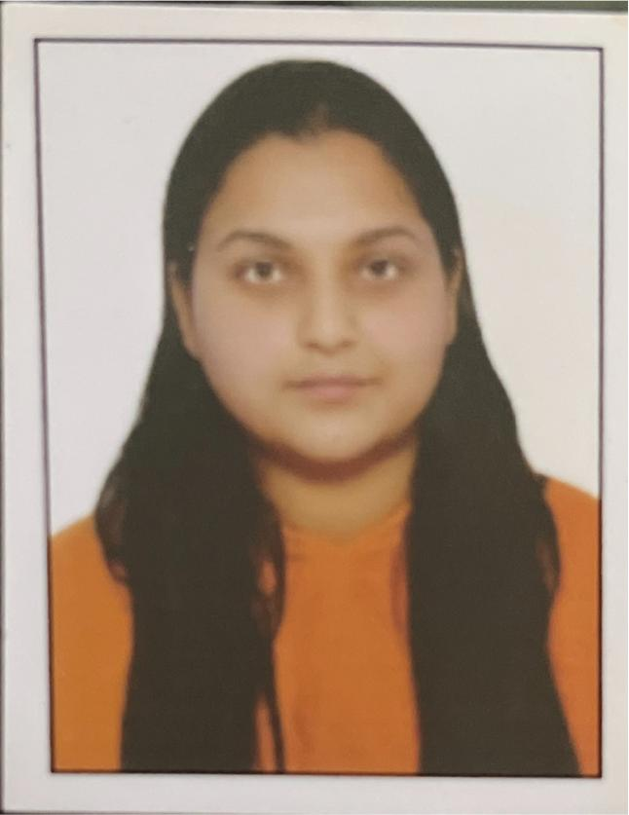
FATHER’S NAME: PARDEEP SINGH
MOTHER’S NAME: PREM KUMARI
 | UG Roll Number
 | H-2019-05-001

NAME: AASHIMA SOOD | Batch 2019- 2023
 | 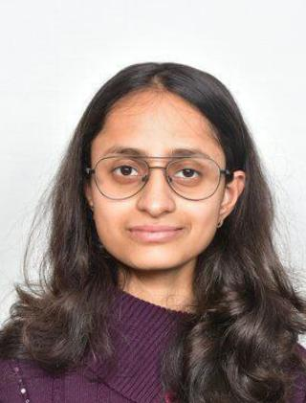
FATHER’S NAME: ASHWANI SOOD
MOTHER’S NAME: SHALINI SOOD
 | UG Roll Number
 | H-2019-05-002

NAME: Aayush kataria | Batch 2019-2023___
 | 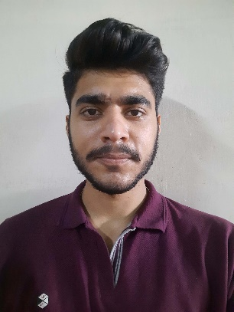
FATHER’S NAME: Narender kataria
MOTHER’S NAME: Jyoti kataria
 | UG Roll Number
 | H-2019-05-003

NAME: AAYUSH THAKUR | Batch 2019-2023
 | 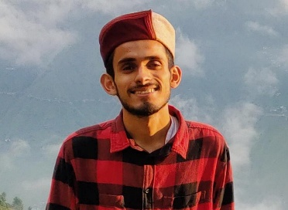
FATHER’S NAME: : Sh.ChanderkantMandhotra
MOTHER’S NAME: Shmt. Reenu Devi
 | UG Roll Number
 | H-2019-05-004

NAME: Abhishek Rana | Batch: 2019-2023
 | 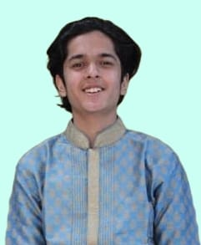
FATHER’S NAME: Dinesh Rana
MOTHER’S NAME: Raksha Rana
 | UG Roll Number
 | H-2019-05-005

NAME: Abhishek Sharma | Batch: 2019-2023
FATHER’S NAME: Ashok Kumar
MOTHER’S NAME: Ranjna Kumari
 | UG Roll Number
 | H-2019-05-006

NAME: Ajayveer Singh | Batch 2019-2023
 | 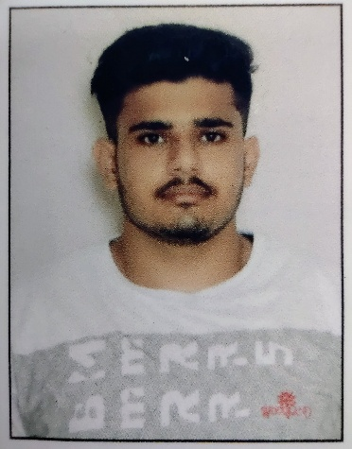
FATHER’S NAME: Sh. Kuldeep Singh
MOTHER’S NAME: Smt. Veena Devi
 | UG Roll Number
 | H-2019-05-007

NAME: Akash Sharma | Batch 2019-2023
 | 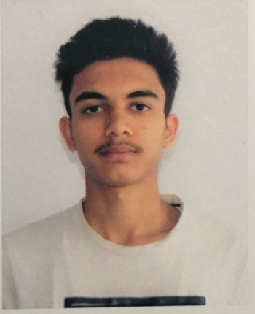
FATHER’S NAME: Suresh Sharma
MOTHER’S NAME: Rajni Kumari
 | UG Roll Number
 | H-2019-05-008

NAME: Akshay Kapoor | Batch 2019-23
FATHER’S NAME: Suneel Kumar Kapoor
MOTHER’S NAME: Anjana Kapoor
 | UG Roll Number
 | H-2019-05-009

NAME: Akshit Kapila | Batch 2019-2023
 | 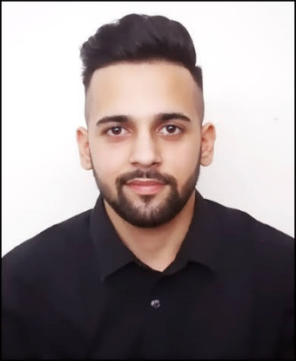
FATHER’S NAME: Satish Kapila
MOTHER’S NAME: Saroj Kapila
 | UG Roll Number
 | H-2019-05-010

NAME  AKSHITA CHANDEL | Batch 2019-..2023
 | 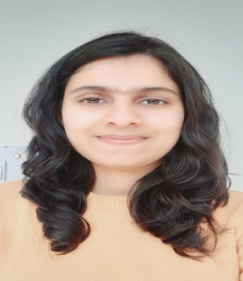
FATHER’S NAME: SHARTENDER SINGH
MOTHER’S NAME: NEELAM CHANDEL
 | UG Roll Number
 | H-2019-05-011

NAME  AMOGH SHARMA | Batch2019-23
 | 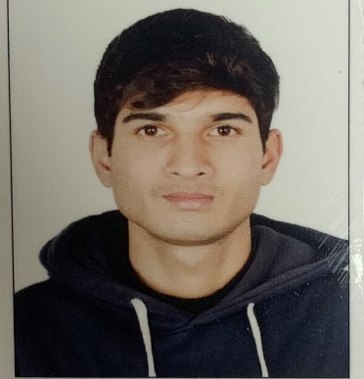
FATHER’S NAME: VINOD KUMAR SHARMA
MOTHER’S NAME: SUMAN SHARMA
 | UG Roll Number
 | H-2019-05-012

NAME  Apurva | Batch 2023
 | 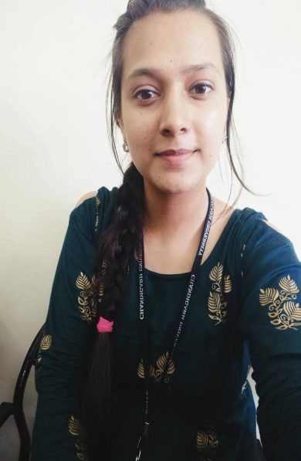
FATHER’S NAME: Mr Santosh Kumar Sharma
MOTHER’S NAME: Mrs Neena Devi
 | UG Roll Number
 | H-2019-05-013

NAME  Arika Thakur | Batch 2019-23
FATHER’S NAME: Chaman singh Thakur
MOTHER’S NAME: Pushpa Thakur
 | UG Roll Number
 | H-2019-05-014

NAME  Arushi Shyam | Batch 2019-2023
FATHER’S NAME: Mr. Ram Lal Shyam

MOTHER’S NAME: Mrs. Reena Shyam
 | UG Roll Number
 | H-2019-05-016

NAME  Ashutosh Kapil | Batch 2019-2023__
FATHER’S NAME: Pritam Chand
MOTHER’S NAME: Anita Devi
 | UG Roll Number
 | H-2019-05-017

NAME-  Ashwani Kumar | Batch 2019-2023……._____
 | 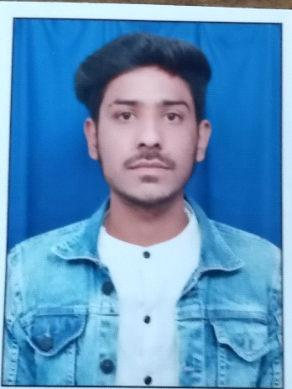
FATHER’S NAME: Kalyan Singh
MOTHER’S NAME: Sunita Devi
 | UG Roll Number
 | H-2019-05-018

NAME  Avinash Thakur | Batch 2019-2023
 | 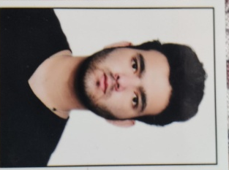
FATHER’S NAME: Sh. Dalip Singh
MOTHER’S NAME: Smt. Maya Devi
 | UG Roll Number
 | H-2019-05-019

NAME  Harshit | Batch 2023
FATHER’S NAME: Rajesh Kumar
MOTHER’S NAME: Suman
 | UG Roll Number
 | H-2019-05-020

NAME  ISHITA | Batch 2019-2023
 | 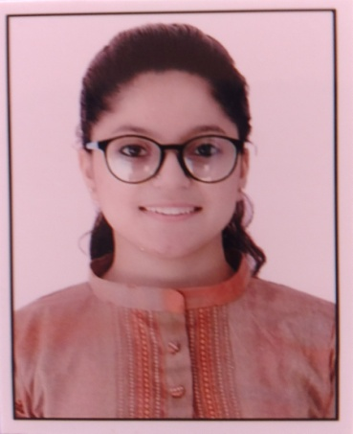
FATHER’S NAME: MR. JATENDER KUMAR
MOTHER’S NAME: MRS. AMITA DEVI
 | UG Roll Number
 | H-2019-05-021

NAME  Jasmeet Singh | Batch 2019-2023
 | 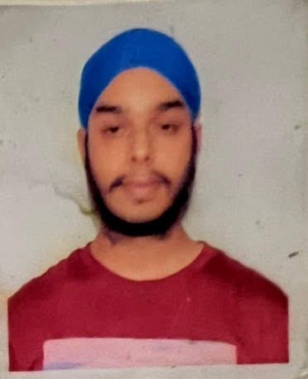
FATHER’S NAME: Sh. Kulbir Singh
MOTHER’S NAME: Smt. Taucharan Kaur
 | UG Roll Number
 | H-2019-05-022
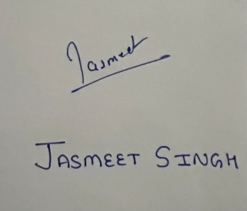

NAME  KANAK SOOD | Batch 2019-2023
 | 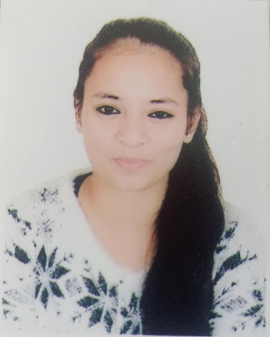
FATHER’S NAME: VIVEK SOOD
MOTHER’S NAME: BINDIYA SOOD
 | UG Roll Number
 | H-2019-05-023

NAME  Kanika Sharma | Batch 2019-2023
 | 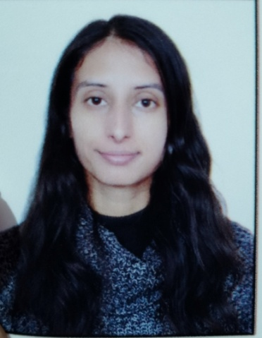
FATHER’S NAME: Sh. Suresh kumar
MOTHER’S NAME: Smt. Sunita Sharma
 | UG Roll Number
 | H-2019-05-024

NAME  Kashish Negi | Batch: 2019-2023
FATHER’S NAME: Surat Singh Negi
MOTHER’S NAME: Sita Devi Negi
 | UG Roll Number
 | H-2019-05-025

NAME  Keshav Jaswal | Batch: 2019-2023
FATHER’S NAME: Joginder Singh
MOTHER’S NAME: Usha Devi
 | UG Roll Number
 | H-2019-05-026

NAME  Kshema Dogar | Batch 2019-2023
 | 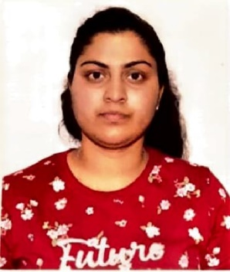
FATHER’S NAME: Late Sh Vivek Dogar
MOTHER’S NAME: Smt Sugam Dogar
 | UG Roll Number
 | H-2019-05-027

NAME  LAKSHAY PATHANIA | Batch 2019 - 2023
 | 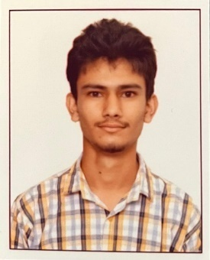
FATHER’S NAME: Mr. SUDHIR PATHANIA
MOTHER’S NAME: Mrs SUSHMA PATHANIA
 | UG Roll Number
 | H-2019-05-028

NAME: Mansimran Kaur | Batch 2019-2023
 | 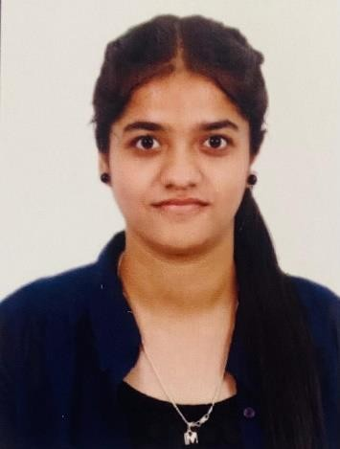
FATHER’S NAME: Narjeet Singh
MOTHER’S NAME: Gurvinder Kaur
 | UG Roll Number
 | H-2019-05-029

NAME:  Meenakshi kashyap | Batch 2019-2023
 | 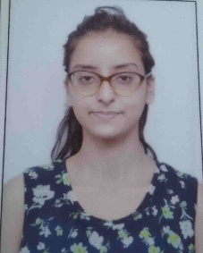
FATHER’S NAME: Sh. Ajay Kumar
MOTHER’S NAME: Shm. Meenakashyap
 | UG Roll Number
 | H-2019-05-030

NAME  Mehak Kothari | Batch 2019 – 2023
FATHER’S NAME: Sh. Roop singh

MOTHER’S NAME: Mrs. Kamlesh Kumari
 | UG Roll Number
 | (H-2019-05-031)

NAME : Minal | Batch 2019-2023
 | 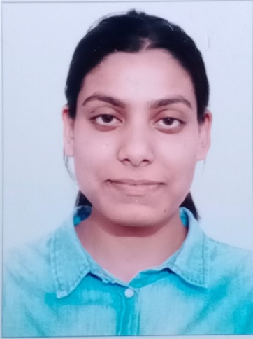
FATHER’S NAME: Sh. Nardev Singh
MOTHER’S NAME: Smt. Meena
 | UG Roll Number :
 | H-2019-05-032

NAME  Naren | Batch 2019-2023
 | 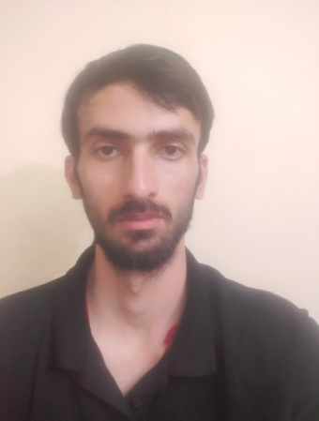
FATHER’S NAME: Naveen Datt
MOTHER’S NAME: Usha
 | UG Roll Number
 | H-2019-05-033

NAME  Nitika Joshi | Batch 2019-2023
 | 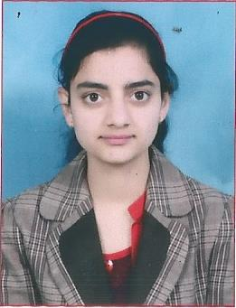
FATHER’S NAME: Narinder Joshi
MOTHER’S NAME: Sarita Sharma
 | UG Roll Number
 | H-2019-05-034

NAME  PRATISTHA GUPTA | Batch 2019-2023
 | 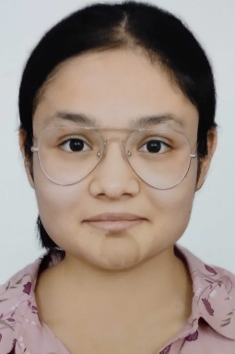
FATHER’S NAME: ASHWANI GUPTA
MOTHER’S NAME: PRIYANKA GUPTA
 | UG Roll Number
 | H-2019-05-035

~~~~~~~~~~~~~~~~~~~~~~~~~~~~~~~~~~~~~~~~~~~~~~~~~~~~~~~~~~~~~~~~~~~~~~~~~~~~~~~~~~~
NAME: Ramna | Batch 2019 - 2023
 | 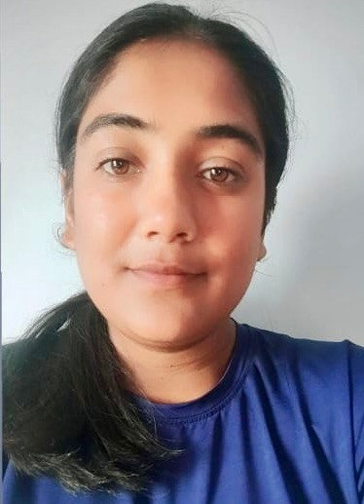
FATHER’S NAME: Mr. Gian chand

MOTHER’S NAME: Mrs. Salochana devi
 | UG Roll Number
 | H-2019-05-036

NAME  RIDHI AWASTHI | Batch: 2019-2023
 | 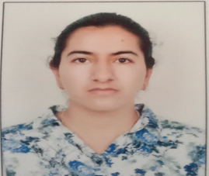
FATHER’S NAME: S P Awasthi
MOTHER’S NAME: Durgesh Awasthi
 | UG Roll Number
 | H-2019-05-037

NAME  RitikSingh | Batch 2019-2023
 | 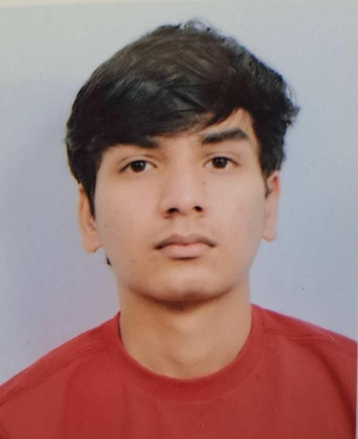
FATHER’S NAME: Ranjit Singh
MOTHER’S NAME: Sulochna Singh
 | UG Roll Number
 | H-2019-05-038

NAME  Riya Sharma | Batch 2019-2023
 | 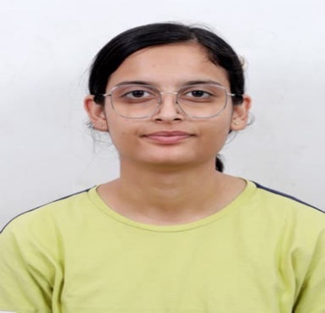
FATHER’S NAME: Chaman lal alias CL Sharma
MOTHER’S NAME: Lata Sharma
 | UG Roll Number
 | H-2019-05-039

NAME  Sahil kumar | Batch 2019-2023
 | 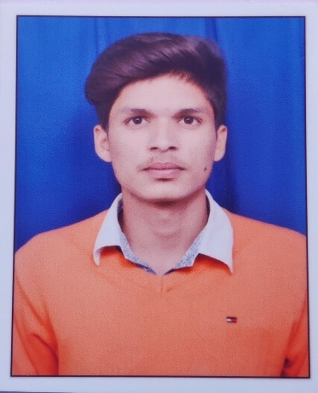
FATHER’S NAME: Nagender kumar
MOTHER’S NAME: Maya devi
 | UG Roll Number
 | H-2019-05-040

NAME: Sakshi | Batch 2019-2023
 | 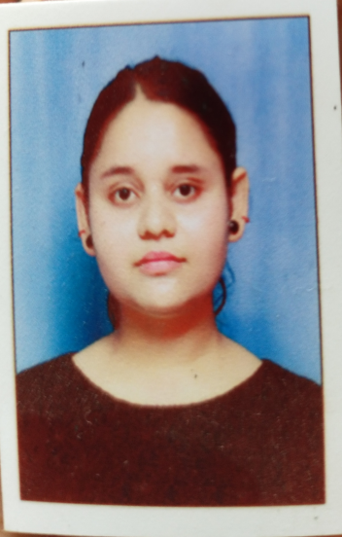
FATHER’S NAME: Mr.Anil Kumar
MOTHER’S NAME: Mrs.Rekha Kumari
 | UG Roll Number
 | H-2019-05-041

NAME  SAKSHI SHARMA | Batch 2019-2023
 | 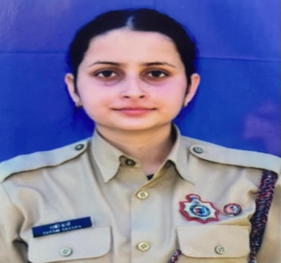
FATHER’S NAME: SANJEEV KUMAR
MOTHER’S NAME: URMILA DEVI
 | UG Roll Number
 | H-2019-05-042

NAME  SARAH PATHANIA | Batch 2019-2023
 | 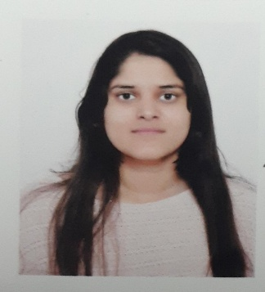
FATHER’S NAME: Mr. PRADEEP PATHANIA
MOTHER’S NAME: Mrs. PRIYA PATHANIA
 | UG Roll Number
 | H-2019-05-043

NAME  Sarbjot Singh | Batch: 2019-2023
 | 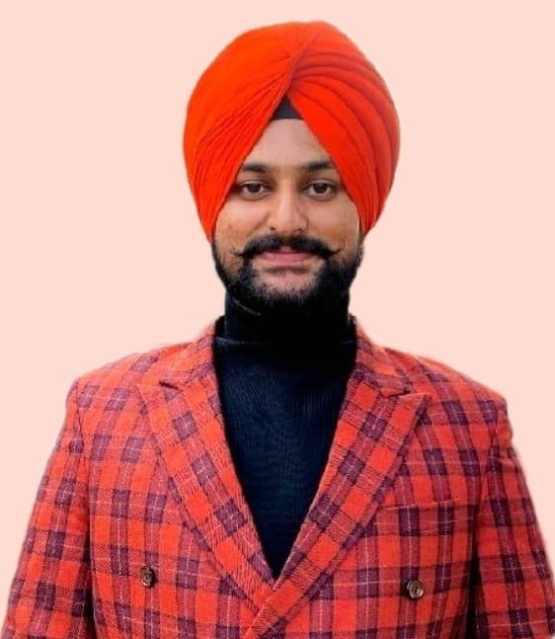
FATHER’S NAME: Parmjit Singh
MOTHER’S NAME: Jasbir Kaur
 | UG Roll Number
 | H-2019-05-044

NAME: Sejal Rana | Batch: 2019-2023
FATHER’S NAME: Surender Kumar
MOTHER’S NAME: Sanju Devi
 | UG Roll Number
 | H-2019-05-046

NAME  Shagun Guleria | Batch 2019-2023
 | 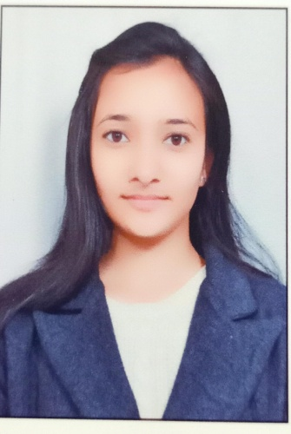
FATHER’S NAME: Gulshan Guleria
MOTHER’S NAME: Babita Guleria
 | UG Roll Number
 | H-2019-05-047

NAME  Shishir Soni | Batch 2019-2023
FATHER’S NAME: Naveen Kumar
MOTHER’S NAME: Monika
 | UG Roll Number
 | H-2019-05-048

NAME  Shivam Sood | Batch 2019-2023___
FATHER’S NAME: Vijay sood
MOTHER’S NAME: Sneh lata
 | UG Roll Number
 | H-2019-05-049

NAME  Shivani | Batch 2019 – 2023
 | 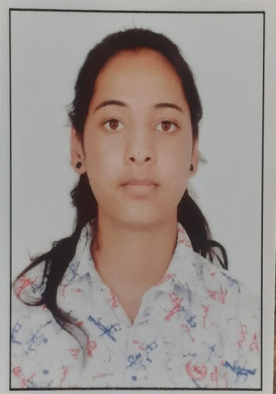
FATHER’S NAME: Mr. Naresh Kumar

MOTHER’S NAME: Mrs. Rashma Devi
 | UG Roll Number
 | H-2019-05-050

NAME  Simran Thakur | Batch 2019-23
 | 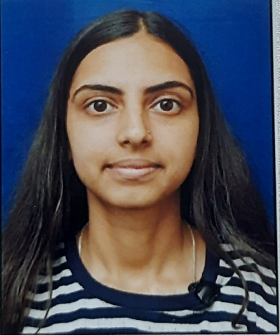
FATHER’S NAME: Sh. Madan Lal Thakur
MOTHER’S NAME: Smt. Pratima Thakur
 | UG Roll Number
 | H-2019-05-051

NAME  Siya Sen | Batch: 2019-2023
 | 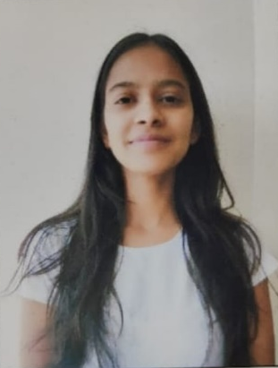
FATHER’S NAME: Uday Singh Sen
MOTHER’S NAME: Seema Sen
 | UG Roll Number
 | H-2019-05-052

NAME  SnehaKoundal | Batch 2019-2023…._____
 | 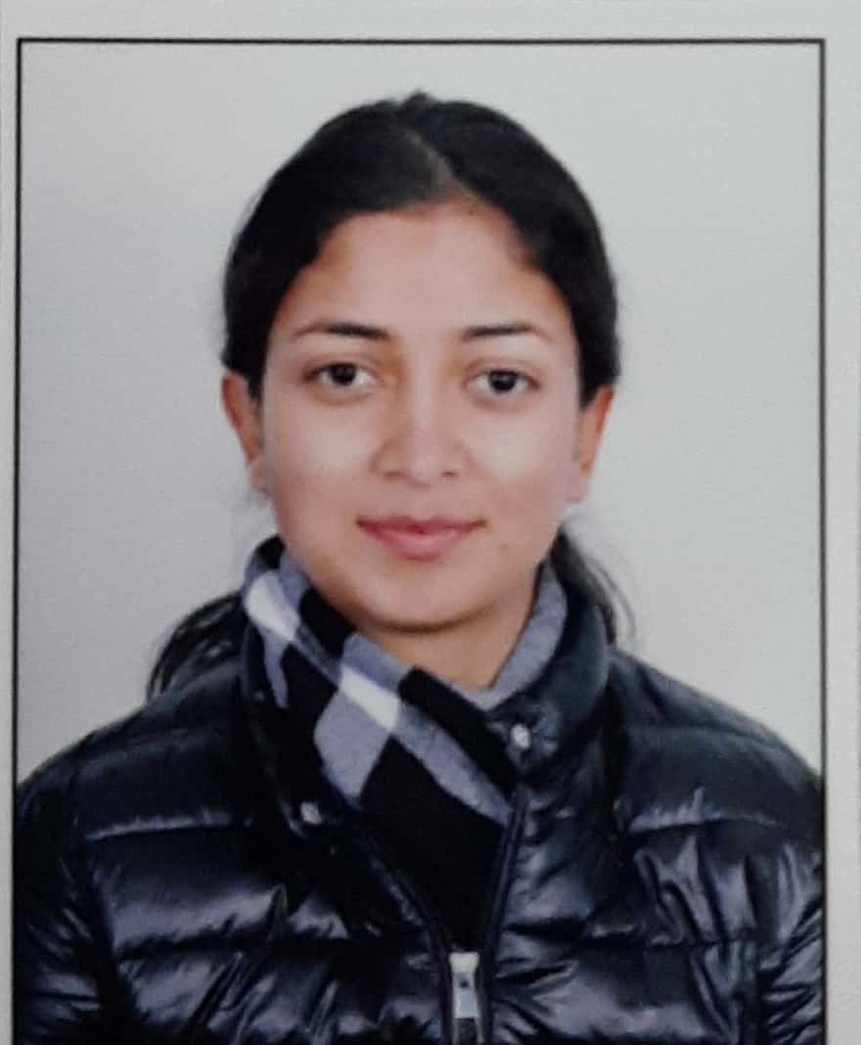
FATHER’S NAME : Mr. Ashok Kumar
MOTHER’S NAME: Mrs.Daya Devi
 | UG Roll Number
 | H-2019-05-053

NAME  Sparsh Parmar | Batch 2019-2023……._____
 | 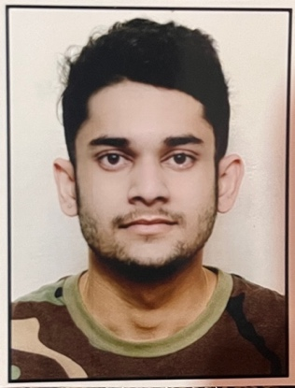
FATHER’S NAME: ArvindParmar
MOTHER’S NAME: SeemaParmar
 | UG Roll Number
 | H-2019-05-054

NAME  SrijalParmar | Batch 2019-2023
 | 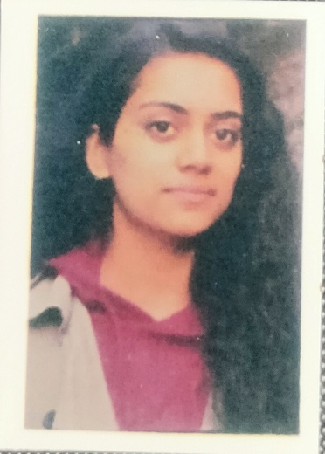
FATHER’S NAME: Surinder Singh
MOTHER’S NAME: SobnaKumari
 | UG Roll Number
 | H-2019-05-055

NAME: Tanvi | Batch 2019-2023
 | 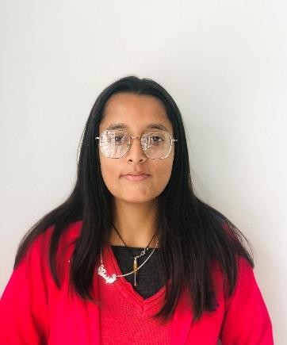
FATHER’S NAME: Karnail Singh

MOTHER’S NAME: Krishna Sahota
 | UG Roll Number
 | H-2019-05-056

NAME : Vaishali Rana | Batch 2019-2023
 | 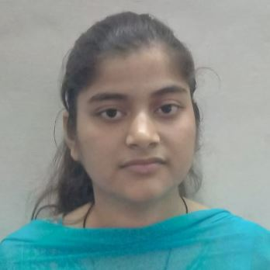
FATHER’S NAME: Sh. Sanjeev Kumar
MOTHER’S NAME: Smt. Shakuntla Devi
 | UG Roll Number
 | H-2019-05-057

NAME  Vanshika | Batch 2019-2023
 | 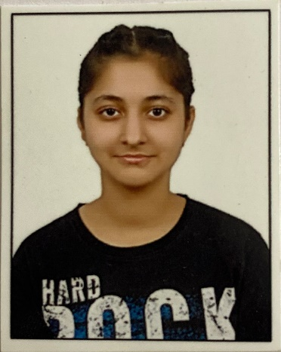
FATHER’S NAME: Pardeep Kumar
MOTHER’S NAME: Sarita Sharma
 | UG Roll Number
 | H-2019-05-059

